## 

## **Khulna University of Engineering and Technology**

### **Department of**

### **Electronics and Communication Engineering**

### **Project Report On: Parabolic Reflector Antenna**

**Course No.**  **: ECE 3208**

**Course Title : Antenna Engineering Laboratory**

**Submission Date : 28.09.22**

|  |  |
| --- | --- |
| **Submitted by**Nasim MahbubRoll: 1809042Faria ParvinRoll: 1809043Abdullah Al JehanRoll: 1809044Department of ECE, KUET | **Submitted to**Dr. Md. Mostafizur RahmanProfessorDepartment of ECE, KUETMd. Ebtidaul KarimAssistant ProfessorDepartment of ECE, KUET |

**Abstract**

An antenna is deﬁned by Webster’s Dictionary as “a usually metallic device (as a rod or wire) for radiating or receiving radio waves.” In other words, the antenna is the transitional structure between free space and a guiding device. Antenna is essential for radio or wireless communication. The parabolic reflector antenna which is often called the dish antenna is the form of antenna which finds many uses in domestic satellite television reception, terrestrial microwave data links, general satellite communications, radio communications and many more.

In our project, the objective is to create an parabolic reflector antenna with 10.2 GHz operating frequency using CST studio software. After which, we are to study different parameters of it and analyze them accordingly.

## 

## **Introduction**

A parabolic Reflector antenna is called such because of having the shape of a paraboloid that is used to collect and re-radiate electromagnetic energy is known as. It is regarded as the simplest and one of the most popular forms of reflector antenna. The parabolic reflector antenna or dish antenna is known for its distinctive shape, its high gain, and narrow beamwidths. This antenna performs really well in higher frequencies for which, it is so popular in HF applications. In view of its operation, these antennas are generally used for UHF, microwave and millimetre wave operation.

It has relatively basic working concept having two main components that are radiating element and reflector. The radiating element may be a simple dipole or a horn antenna. The reflector is the distinctive part of the parabolic reflector antenna. It has the shape of parabola. The crucial function of the parabolic reflector is to change the incident spherical wave into a planewave.

Here we have designed and simulated a parabolic reflector antenna that works at 10.2GHz frequency and as for the feeding element we have used a horn antenna with rectangular waveguide.

## **Methodology and Working constraints**

The main terms we will find while working on the antenna are,

1. **Focus** The focus or focal point of the parabolic reflector is the point at which any incoming signals are concentrated. When radiating from this point the signals will be reflected by the reflecting surface and travel in a parallel beam and to provide the required gain and beamwidth.
2. **Vertex** This is the innermost point at the centre of the parabolic reflector.
3. **Focal length** The focal length of a parabolic antenna is the distance from its focus to its vertex.
4. **Aperture** The aperture of a parabolic reflector is what may be termed its "opening" or the area which it covers. For a circular reflector, this is described by its diameter. It can be likened to the aperture of an optical lens.
5. **Feed system** The parabolic reflector or dish antenna can be fed in a variety of ways. Axial or front feed, off axis, Cassegrain, and Gregorian are the four main methods.

### **Working Principle**

Consider a parabolic reflector used for transmitting a signal, the feed element is present at the focus. So, at the focus when a feed antenna is placed which is nothing but an isotropic source then the waves are emitted from the source. The radiating element used at the focus is generally a horn antenna, which is used to illuminate the reflecting surface. Thus, the waves emitted from the source, incident on the surface of the reflector and are further reflected back as a plane wave of circular cross-section.

Now let’s discuss the design parameters.

The Half power Beam width HPBW = 58λ/D

First null Beam width BWFN = 140λ/D

D = 4π(maximum radiation intensity) / total radiation power.

The ratio of focal length to aperture size is an important constraint for parabolic antenna design which should be between 0.25 to 0.50.

The model of the antenna is designed with perfect electric conductor (PEC) as the material. CST has a number of solvers in both its frequency and time domain. However, in this project, only transient solver is used which is time domain solver. The antenna is front-fed by a rectangular horn waveguide antenna with a rectangular waveguide feed. The antenna is working at 10.2 GHz.

The parameters we have used to design it are listed in the table below,

**Table-1: Parameter lilst**

|  |  |
| --- | --- |
| Name | Value(mm) |
| A | 0.002 |
| R | 120 |
| Rt | 5 |
| F | 111.8 |
| Lf | 44 |
| Lg | 20 |
| Wg | 17 |
| Hg | 12 |
| Wa | 28 |
| Ha | 24.2 |
| Mt | 0.95 |
| Rs | 0.5 |

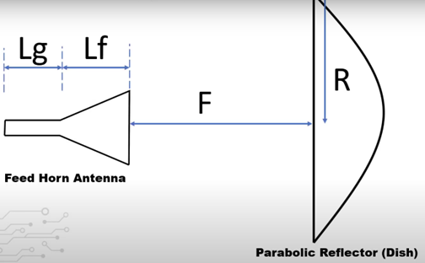 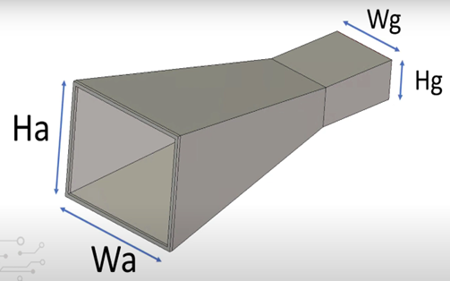

Fig 1: Horn Antenna

The simulation takes up about 8 hours to complete with default mesh properties.

Depth of reflector=32.2 mm

Focus f = D^2/16d = 240^2/(16∗32.2) = 111.8 mm

“focal length to aperture size ratio" is = f/2R = 111.8/240 = 0.47

The final design of our antenna is,

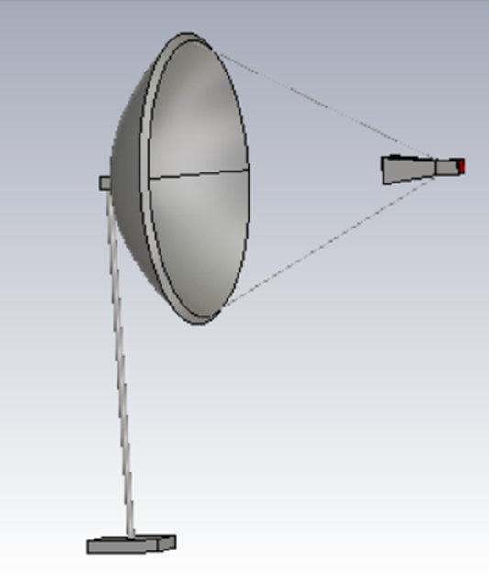

Fig 2: Parabolic reflector antenna

## 

## **Results:**

In this section, we discuss the obtained result from simulation of the antenna.

### 

### **S parameter:**

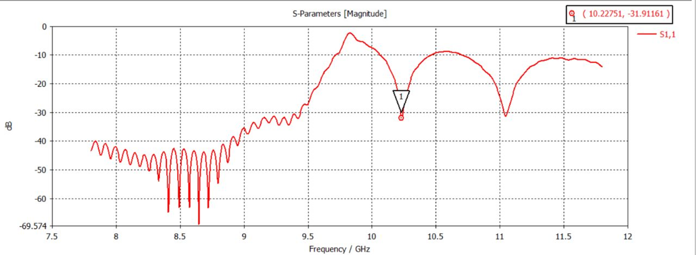

Fig 3: S-parameter S1,1 magnitude vs. frequency

Figure 3 shows S-parameter 1D plot marked at frequency of 10.22751 GHz which is our operating frequency. Generally, the preferred value is in the range of -10 to -20 dB. However, the value less than -10 dB proved that the antenna is transferring the maximum power and thus almost no power is reflected back. Further adjustments can be made to achieve its desired performance by varying the distance of the horn antenna to the reflector, a, size of the antenna, and others.

### 

**VSWR:**

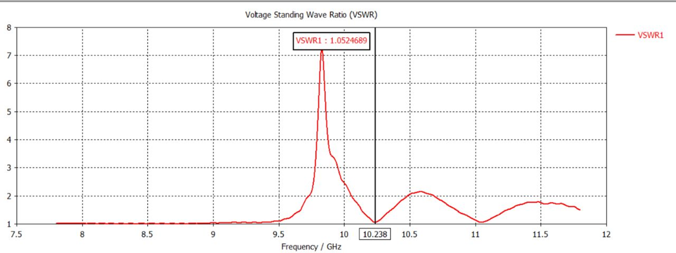

Fig 4: Frequency vs VSWR plot

VSWR (Voltage Standing Wave Ratio), is a measure of how efficiently radio-frequency power is transmitted from a power source, through a transmission line, into a load.For an antenna operation the VSWR(Voltage Standing Wave Ratio) should be in between 1 and 2 .In our antenna design the VSWR is 1.0524689 and it shows that our antenna is working properly.

### **Radiation Pattern in 2D:**

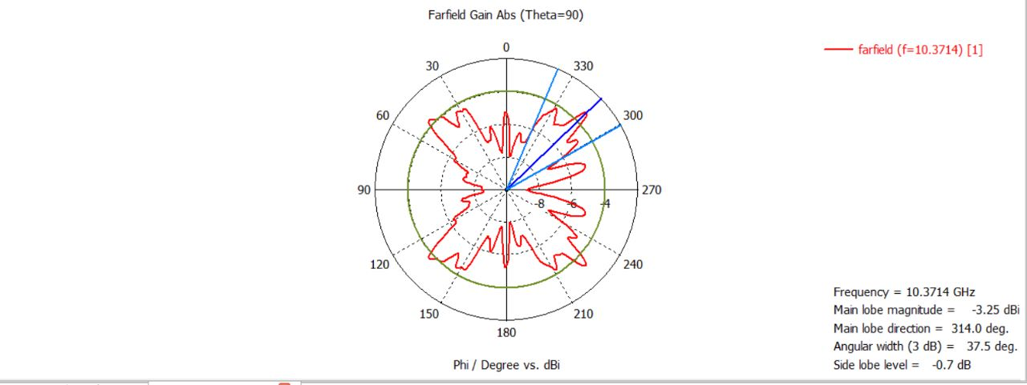

Fig 5: Far-field Radiation pattern in polar form.

The Far field radiation pattern in polar form indicates that the main lobe which resembles correct signal radiation is bigger than the side lobe level. It indicates a good sign of directivity. This is a good result of directivity because the signal radiates straight at the center and less signal radiates on its side avoiding from signal loss.

### **Radiation Pattern in 3D:**

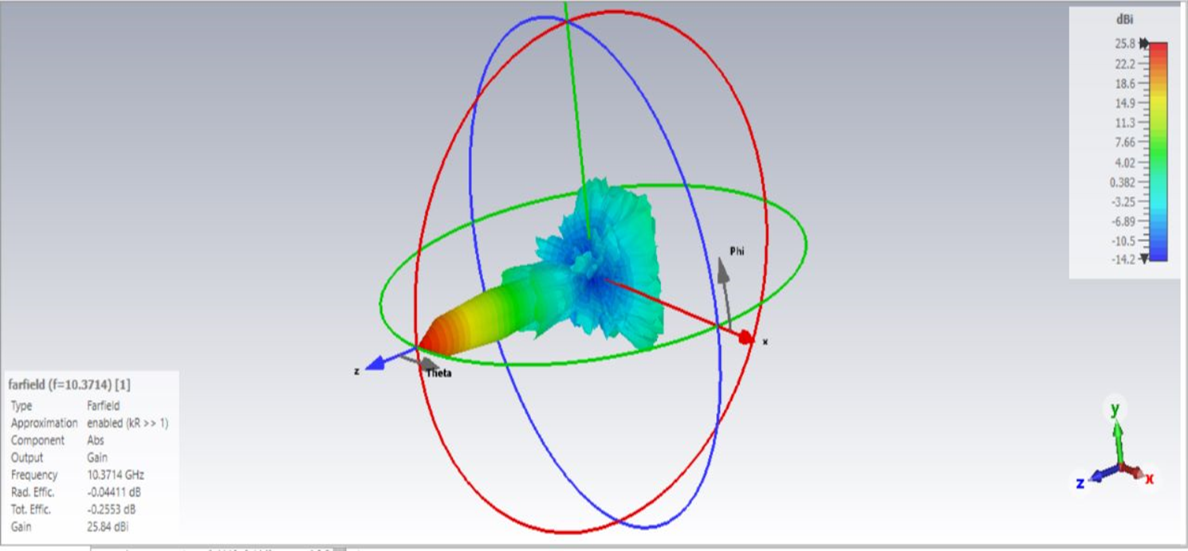

Fig 6: Far-field radiation pattern in 3D.

### **Antenna Gain:**

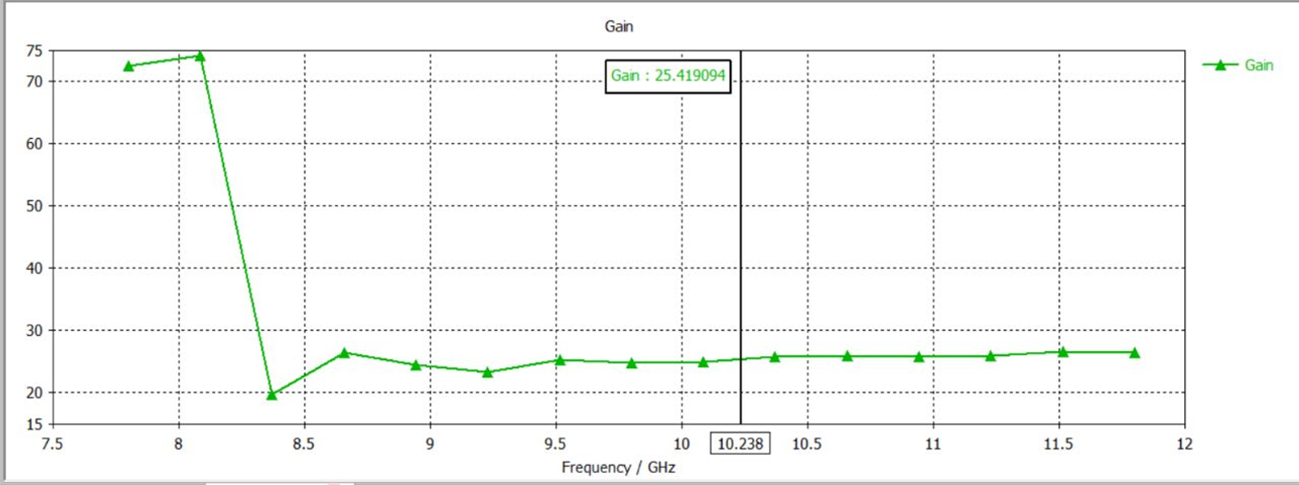

Fig 7: Gain pattern

Antenna gain indicates how strong a signal of an antenna can send or receive in a specified direction.

In parabolic reflector, antenna we can achieve our gain about 30 dB. From this figure, We can see the Gain of our Antenna is 25.419094 dB. For the shortage of enough frequency, our gain isn’t perfectly enough.

### **Antenna Directivity:**

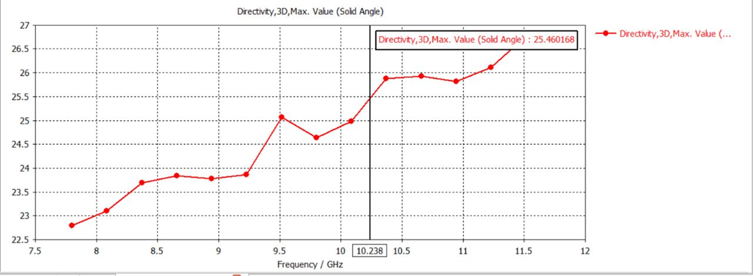

Fig 8: Directivity pattern.

Directivity is the measure of concentration of antenna’s radiation pattern in a particular direction. From this figure we can see that our directivity is 25.4601 dB.

### **E Field:**

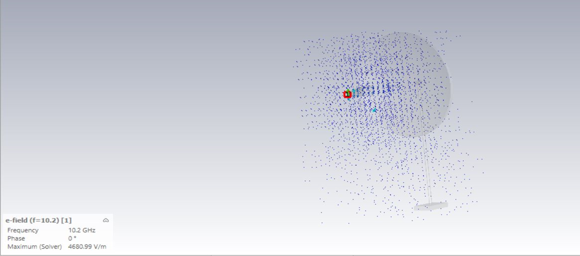

Figure 9: E field of the antenna.

### **H Field:**

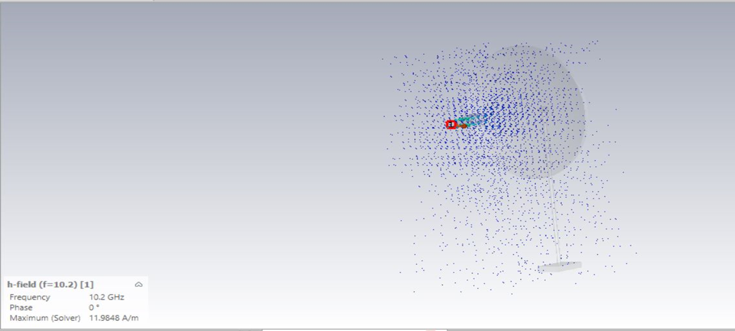

Figure 10: H field of the antenna.

### **Surface Current:**

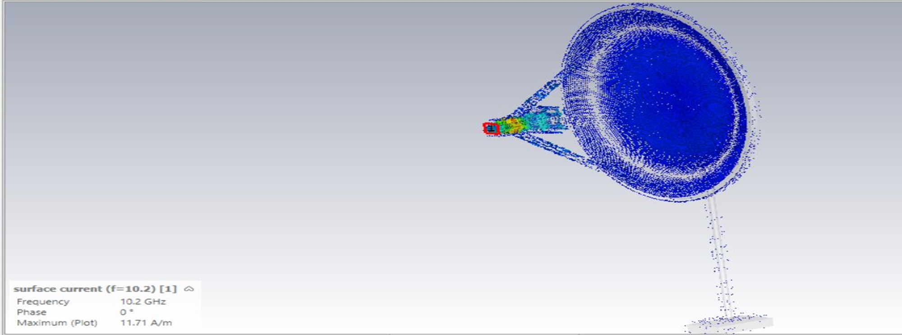

Figure 11: Surface current of the antenna.

## **Advantage:**

Some of the major advantages of the parabolic reflector antenna include the following:

* **High gain*:*** Parabolic reflector antennas are able to provide very high levels of gain. The larger the 'dish' in terms of wavelengths, the higher the gain.
* **High directivity*:***  As with the gain, so too the parabolic reflector or dish antenna is able to provide high levels of directivity. The higher the gain, the narrower the beamwidth. This can be a significant advantage in applications where the power is only required to be directed over a small area. This can prevent it, for example causing interference to other users, and this is important when communicating with satellites because it enables satellites using the same frequency bands to be separated by distance or more particularly by angle at the antenna.
* It can be used **both** as **transmitting** antenna and **receiving** antenna due to principle of reciprocity.
* It reduces minor lobes.
* Easy beam adjustment is possible with it.

## **Disadvantages**

Like all forms of antenna, the parabolic reflector has its limitations and drawbacks:

* **Requires reflector and drive element*:*** the parabolic reflector itself is only part of the antenna. It requires a feed system to be placed at the focus of the parabolic reflector.
* **Cost:**  The antenna needs to be manufactured with care. A paraboloid is needed to reflect the radio signals which must be made carefully. In addition to this, a feed system is also required. This can add cost to the system.
* **Size:** The antenna is not as small as some types of antenna, although many used for satellite television reception are quite compact.
* The size of the structure quite large.
* The small element of paraboloid causes some amount of power obstruction.

## **Application**

Here is many areas in which the parabolic dish antenna is used. In some areas, it is the form of antenna that is used virtually exclusively because of its characteristics.

* **Direct broadcast television:** Direct broadcast or satellite television has become a major form of distribution for television content. The wide and controllable coverage areas available combined with the much larger bandwidths enable more channels to be broadcast and this makes satellite television very attractive.
* **Microwave links:** Terrestrial microwave links are used for many applications. Often they are used for terrestrial telecommunications infrastructure links. One of the major areas where they are used these days is to provide the backhaul for mobile telecommunications systems.
* **Satellite communications & SpaceCraft communication:** Many satellite uplinks, or those for communication satellites require high levels of gain to ensure the optimum signal conditions and that transmitted power from the ground does not affect other satellites in close angular proximity. Again the ideal antenna for most applications is the parabolic reflector antenna.
* **Radio astronomy:** Radio astronomy is an area where very high levels of gain and directivity are required. Accordingly, the parabolic reflector antenna is an ideal choice.

## **Conclusion**

In this project, our goal was to design a parabolic reflector antenna at a given frequency. Although we were given 12 GHz operating frequency, due to shortage of our computer RAM we could not achieve it. We reduces the frequency to 10.2 GHz and then simulated it. And we measured all the essential parameter which showed values within the suitable range for working it properly. So it can be said that, we have successfully designed a parabolic reflector antenna which is working quite smoothly and our project was completed with all the objective fulfilled.

## **References**

* <https://www.electronics-notes.com/articles/antennas-propagation/parabolic-reflector-antenna/parabolic-dish-basics.php>
* <https://en.wikipedia.org/wiki/Parabolic_antenna#:~:text=A%20parabolic%20antenna%20is%20an,dish%20antenna%20or%20parabolic%20dish>.
* <https://www.tutorialspoint.com/antenna_theory/antenna_theory_parabolic_reflector.htm>